Cochlear Implant Telephone Adaptors
These accessories can help users with a cochlear implant to hear phone calls more clearly by eliminating background noise and interference.
Type of accessory: Cochlear Implant Telephone Adaptor for landlines and mobiles
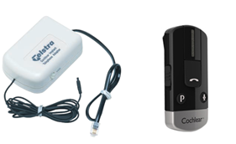
How do you use these accessories?
Connect the telephone adaptor to the phone so the telephone adaptor acts as a bridge between the phone and your cochlear device. You can then connect your cochlear device to the phone adaptor so the sound is transmitted directly to your cochlear implant.
This accessory connects to phones via:
Audio Jack: No
Bluetooth: Yes (some models)
Wi-Fi: No
Micro USB: No
Other: Standard Telephone cable (some models)

Is there any other piece of equipment required for this accessory to work properly with a phone?
No, it does not require any additional equipment to connect or work properly with a phone. But you might need additional equipment to connect to your cochlear device to the phone adaptor if your device does not allow wired connections.

Compatibility:
One telephone adaptor works with landline phones and one works with mobiles and landlines.
Cochlear Implant Telephone Adaptors for Landlines available in Australia:
1. Telstra Cochlear Implant Telephone Adaptor - landlines
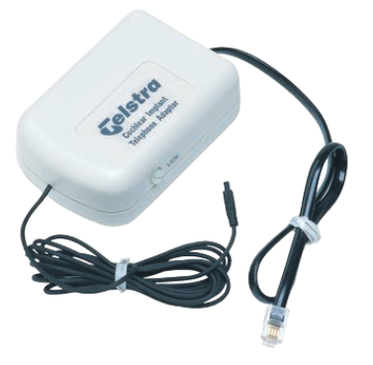
The Telstra Cochlear Implant Telephone Adaptor connects to the handset socket on base of your phone, and then it connects directly to the Nucleus 5 and Nucleus 6 sound processors, via the cable, to the socket on the processor.
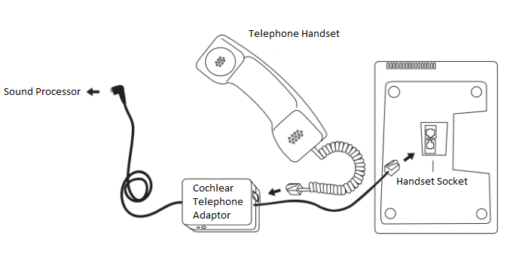

Features:
- The adaptor eliminates interference and background noise from the telephone conversation and provides a clearer signal.
- Handset selector switch provides compatibility with a wide range of telephones including models that have detachable handsets.

More information at: Telstra Disability Equipment Program PDF Brochure
Available at: Telstra Disability Equipment Program.
Is there any training available for this accessory?
Installation and instructions of use might be available directly from Telstra.

2. Cochlear / Resound Wireless Phone Clip – landlines and mobiles
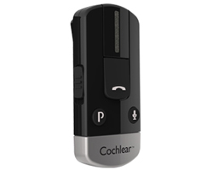

The Cochlear/Resound Phone Clip works with both Cochlear branded cochlear implants as well as with some GN Resound hearing aids. It is compatible with BAHA 5, Kanso, Nucleus 6, and Nucleus 7 sound processors.
It can connect to mobiles and landline phones with Bluetooth capabilities.
In this mode, the phone clip is connected wirelessly to both the sound processor and the landline phone.
*Use our Device Search Page to search for landline phones with Bluetooth capabilities!

Features:
- 6 hours of talk time
- 80 hours of standby time
- Call reject and tracker, last number dialled and voice dial functions
- Simultaneous connection to two Bluetooth devices (such as your smartphone and tablet)
- Quality stereo sound when streaming music
- Private and secure connection

More information at: Cochlear Wireless Phone Clip Web Page
Available at: My Cochlear Store
Is there any training available for this accessory?
Training and demonstrations are available at Cochlear clinics.

